**TAMIL SCRIPT**

**https://24x7offshoring.com/**

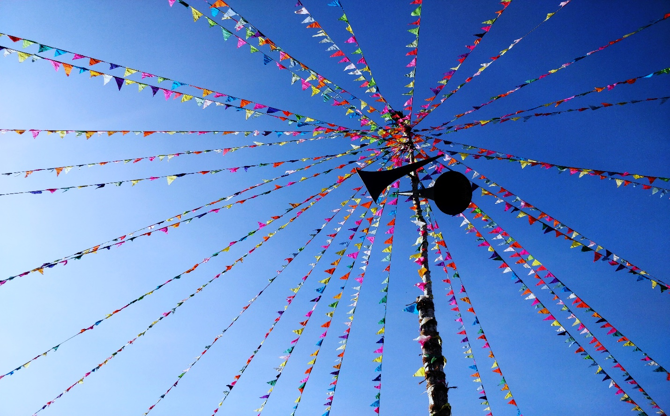[**http://24x7outsourcing.com/**](http://24x7outsourcing.com/)

**Tamil Writing System**

After Tamil Brahmi dropped out of utilization, Tamil was composed utilizing a content called the vaṭṭeḻuttu among others.

**Example**

For example, Grantha and Pallava content.

The current Tamil content comprises of 12 vowels, 18 consonants and one uncommon character, the āytam.

**Grantha alphabet**

Grantha letters in order, composing arrangement of southern India created in the fifth century AD and still being used. The soonest engravings in Grantha, dating from the fifth sixth century AD, are on copper plates from the realm of the Pallavas (close to current Madras).

The type of the letters in order utilized in these engravings, delegated Early Grantha, and is seen principally on copper plates and stone landmarks. Center Grantha, the type of the content utilized from the mid-seventh to the furthest limit of the eighth century, is likewise known from engravings on copper and stone.

The content utilized from the ninth to the fourteenth century is called Transitional Grantha; from around 1300 on, the cutting edge content has been being used. Right now two assortments are utilized: Brahmanic, or "square," and Jain, or "round."

The Tulu-Malayalam content is an assortment of Grantha dating from the eighth or ninth century AD. The cutting edge Tamil content may likewise be gotten from Grantha, however this isn't sure.

**Vowels and constants**

The vowels and consonants join to shape 216 compound characters, giving a sum of 247 characters (12 + 18 + 1 + (12 x 18)). All consonants have a natural vowel a, similarly as with other Indic contents.

This nature is taken out by adding a bit called a puḷḷi, to the consonantal sign.

**Model**

For instance, ன is ṉa (with the intrinsic a) and ன் is ṉ (without a vowel).

Numerous Indic contents have a comparable sign, conventionally called virama, yet the Tamil content is to some degree diverse in that it almost consistently utilizes a noticeable puḷḷi to show a dead consonant (a consonant without a vowel).

It is safe to say that you are searching for Tamil Translation? We are here for your help.

In other Indic contents, it is for the most part liked to utilize a ligature or a half structure to compose a syllable or a bunch containing a dead consonant, in spite of the fact that composing it with a noticeable virama is likewise conceivable. The Tamil content doesn't separate voiced and unvoiced plosives.

**Tamil phonology**

All things considered, plosives are explained with voice contingent upon their situation in a word, as per the guidelines of Tamil phonology.

Notwithstanding the standard characters, six characters taken from the Grantha content, which was utilized in the Tamil district to compose Sanskrit, are here and there used to address sounds not local to Tamil, that is, words received from Sanskrit, Prakrit and different dialects.

**Customary framework**

The customary framework endorsed by traditional punctuations for composing credit words, which includes respelling them as per Tamil phonology, remains, however isn't in every case reliably applied.

Peruse Also: Tamil Language Translation

**TAMIL SCRIPT**

**https://24x7offshoring.com/**

**http://24x7outsourcing.com/**